**Represent!**

Sung Kyu Park

24290927

# Demo Video :

<https://youtu.be/b6lP9hWDk9E>

# Git Repository :

<https://github.com/cs160-berkeley/prog02b-fa18-skpark-tech>

# ../../Screen%20Shot%202018-10-07%20at%206.19.35%20PM.pngHow it Works :

Simple iconography and red color theme is used throughout.

Used pt-serif-bold font.

**Main view**

User chooses one of the three options:

The ZIPCODE button brings user to *search view*   
with **empty** zip code.

The CURRENT_LOCATION button brings user to   
*search view* with **current** zip code.

The RANDOM_LOCATION button brings user to

*search view* with **random** zip code.

**Search View**

User could then enter the desire zip code to search. If the zip code is invalid, the application renders an error message. Clicking on the search button takes user to the *Congressional View*.

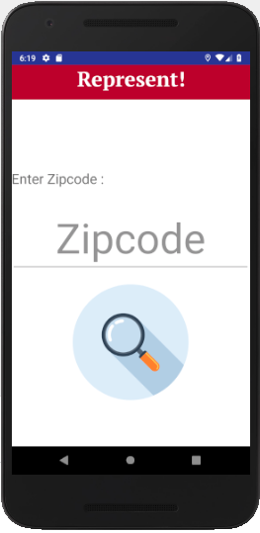 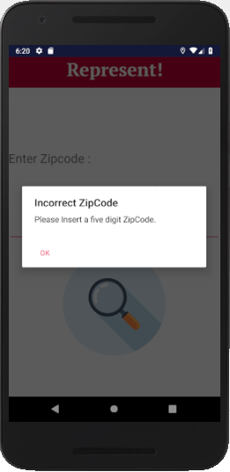

**Congressional View**

Users could scroll down the card list to see all representative’s **name**, **chamber**, **contact**, and **party**. Clicking on contact redirects user to the representative’s page. Clicking on details directs user to the *Detailed View*.

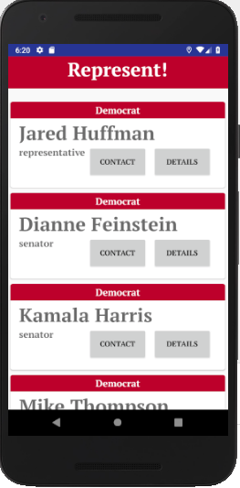 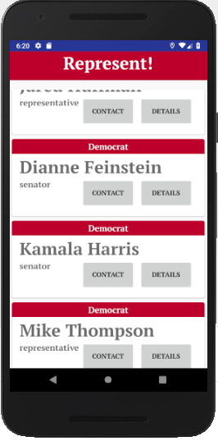

**Detailed View**

Users could see the representative’s **photo**, **bills**, and **committee membership**.

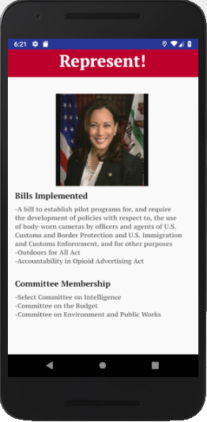

Citations :

Main View image :

<https://www.google.com/url?sa=i&rct=j&q=&esrc=s&source=images&cd=&cad=rja&uact=8&ved=2ahUKEwjxivbb2_XdAhVTHjQIHXDGDAMQjRx6BAgBEAU&url=https%3A%2F%2Fgithub.com%2FFortAwesome%2FFont-Awesome%2Fissues%2F2440&psig=AOvVaw093awzx84X_9K_sLoAb_CR&ust=1539049340581216>

Search View search icon :

<https://www.flaticon.com/packs/seo-and-development-7>